Online Shopping Cart - Part 2
Nicholas Christensen
Colorado State University Global
CSC500: Principles of Programming
Prof. Steven Evans
6/21/2026
Online Shopping Cart - Part 2
This program is the Week 6 milestone of the Online Shopping Cart portfolio project. It builds on the Week 4 ItemToPurchase class by adding a new ShoppingCart class that manages a list of items for a single customer, methods for adding, removing, and modifying items and for computing the total number of items and the total cost, and a menu-driven interface that lets the user interact with the cart until they choose to quit. Invalid menu choices are caught and the user is re-prompted. The program is written in Python (version 3.14) and was developed in Visual Studio Code.
Pseudocode
START
DEFINE class ItemToPurchase WITH item_name, item_price, item_quantity, item_description
DEFINE class ShoppingCart WITH customer_name, current_date, cart_items list
METHOD add_item(item): APPEND item to cart_items
METHOD remove_item(name): FIND item by name and DELETE; else print not-found message
METHOD modify_item(item): FIND by name and UPDATE non-default attributes
METHOD get_num_items_in_cart(): RETURN sum of all item quantities
METHOD get_cost_of_cart(): RETURN sum of price * quantity for each item
METHOD print_total(): PRINT cart contents and total, or SHOPPING CART IS EMPTY
METHOD print_descriptions(): PRINT every item name and description
PROMPT user for customer name and date
CREATE cart AS ShoppingCart with the entered values
CALL print_menu(cart)
FUNCTION print_menu(cart):
LOOP forever
DISPLAY menu options and PROMPT user for choice
IF choice == 'q' THEN RETURN
IF choice not in {a,r,c,i,o,q} THEN print invalid message and CONTINUE
IF 'a': PROMPT for item details, CALL cart.add_item(...)
IF 'r': PROMPT for name, CALL cart.remove_item(name)
IF 'c': PROMPT for name + new quantity, CALL cart.modify_item(...)
IF 'i': CALL cart.print_descriptions()
IF 'o': CALL cart.print_total()
END
Source Code
"""
CSC500 - CT6: Online Shopping Cart Part 2 (Portfolio Milestone, Week 6)
ItemToPurchase + ShoppingCart classes with a menu-driven interface.
Python 3.14.5
"""

class ItemToPurchase:
"""A single item that can be placed in the shopping cart."""

def __init__(self, item_name="none", item_price=0.0,
item_quantity=0, item_description="none"):
self.item_name = item_name
self.item_price = item_price
self.item_quantity = item_quantity
self.item_description = item_description

def print_item_cost(self):
line_total = self.item_price * self.item_quantity
print(f"{self.item_name} {self.item_quantity} @ "
f"${self.item_price} = ${line_total}")

class ShoppingCart:
"""A collection of ItemToPurchase objects belonging to one customer."""

def __init__(self, customer_name="none", current_date="January 1, 2020"):
self.customer_name = customer_name
self.current_date = current_date
self.cart_items = []

def add_item(self, item):
self.cart_items.append(item)

def remove_item(self, name):
for i, item in enumerate(self.cart_items):
if item.item_name == name:
del self.cart_items[i]
return
print("Item not found in cart. Nothing removed.")

def modify_item(self, modified):
for item in self.cart_items:
if item.item_name == modified.item_name:
if modified.item_description != "none":
item.item_description = modified.item_description
if modified.item_price != 0.0:
item.item_price = modified.item_price
if modified.item_quantity != 0:
item.item_quantity = modified.item_quantity
return
print("Item not found in cart. Nothing modified.")

def get_num_items_in_cart(self):
return sum(item.item_quantity for item in self.cart_items)

def get_cost_of_cart(self):
return sum(item.item_price * item.item_quantity
for item in self.cart_items)

def print_total(self):
print(f"{self.customer_name}'s Shopping Cart - {self.current_date}")
if not self.cart_items:
print("SHOPPING CART IS EMPTY")
return
print(f"Number of Items: {self.get_num_items_in_cart()}\n")
for item in self.cart_items:
item.print_item_cost()
print(f"\nTotal: ${self.get_cost_of_cart()}")

def print_descriptions(self):
print(f"{self.customer_name}'s Shopping Cart - {self.current_date}")
print("\nItem Descriptions")
print("-----------------")
for item in self.cart_items:
print(f"{item.item_name}: {item.item_description}")

MENU = """
MENU
a - Add item to cart
r - Remove item from cart
c - Change item quantity
i - Output items' descriptions
o - Output shopping cart
q - Quit"""

def prompt_new_item():
print("ADD ITEM TO CART")
print("Enter the item name:")
name = input()
print("Enter the item description:")
description = input()
print("Enter the item price:")
price = float(input())
print("Enter the item quantity:")
quantity = int(input())
return ItemToPurchase(name, price, quantity, description)

def print_menu(cart):
valid = {"a", "r", "c", "i", "o", "q"}
while True:
print(MENU)
print("\nChoose an option:")
choice = input().strip().lower()
if choice == "q":
return
if choice not in valid:
print("Invalid option. Please choose a, r, c, i, o, or q.")
continue
if choice == "a":
cart.add_item(prompt_new_item())
elif choice == "r":
print("REMOVE ITEM FROM CART")
print("Enter name of item to remove:")
cart.remove_item(input())
elif choice == "c":
print("CHANGE ITEM QUANTITY")
print("Enter the item name:")
name = input()
print("Enter the new quantity:")
quantity = int(input())
cart.modify_item(
ItemToPurchase(item_name=name, item_quantity=quantity))
elif choice == "i":
print("OUTPUT ITEMS' DESCRIPTIONS")
cart.print_descriptions()
elif choice == "o":
print("OUTPUT SHOPPING CART")
cart.print_total()

def main():
print("Enter customer's name:")
name = input()
print("Enter today's date:")
date = input()
cart = ShoppingCart(name, date)
print(f"\nCustomer name: {cart.customer_name}")
print(f"Today's date: {cart.current_date}")
print_menu(cart)

if __name__ == "__main__":
main()
Screenshots
Figure 1
ShoppingCart and ItemToPurchase source code in Visual Studio Code.
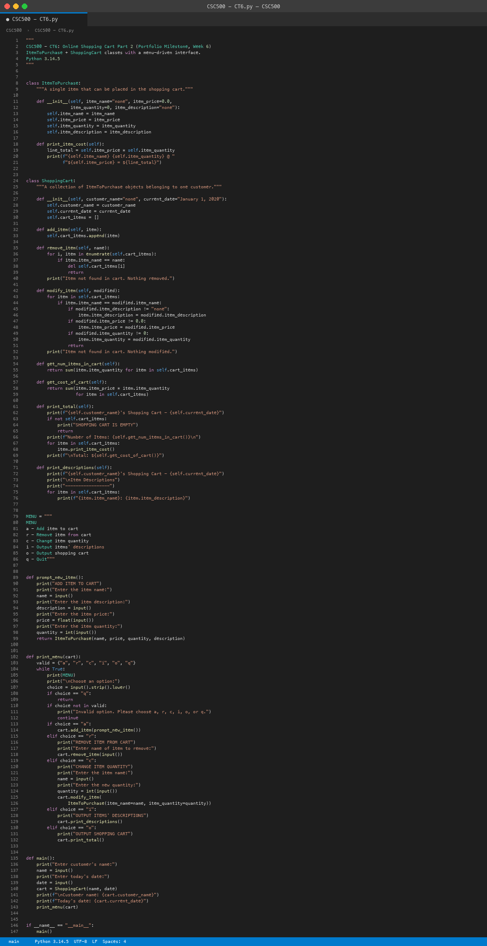
Figure 2
Terminal interaction: menu, item entry, and the Output Shopping Cart result.
